Home Door Biometric Authentication System

By: Patoliya Shyam {141}

Ritam Mishra {165}

Jadhav Pranav {151}

**Abstract:**

This project presents a home door biometric authentication system using a solenoid lock, fingerprint sensor, and Arduino Uno microcontroller. The aim is to enhance home security beyond traditional lock and key systems by leveraging the reliability and uniqueness of fingerprint biometrics. The system uses an Arduino Uno microcontroller to process fingerprint data and control a solenoid lock. If the input fingerprint data matches the stored fingerprint data, the Arduino Uno triggers the solenoid lock to unlock the door.

The proposed system was found to be effective in enhancing home security by successfully authenticating registered users and denying access to unauthorized individuals. This project demonstrates that advanced biometric security can be effectively implemented for home security purposes using affordable and readily available components.

**Introduction:**

In the modern world, security has become a primary concern for everyone. Traditional lock and key systems are no longer considered safe as they can be easily manipulated or duplicated. This has led to the need for more advanced and secure methods of access control. One such method is biometric authentication, which uses unique physical or behavioural characteristics, such as fingerprints, to verify an individual’s identity. This project proposes a home door biometric authentication system using a solenoid lock, fingerprint sensor, and Arduino Uno microcontroller.

* **Background**

The advent of technology has made it possible to use biometric features In the modern world, security has become a primary concern for everyone. Traditional lock and key systems like fingerprints for authentication purposes. Fingerprint recognition is considered one of the most reliable biometric technologies as it is easy to use, difficult to forge, and each individual’s fingerprint pattern is unique. The proposed system leverages this technology to enhance home security.

* **Problem Statement**

Traditional home security systems are often vulnerable to breaches due to lost keys, stolen access cards, or cracked passwords. Moreover, they do not provide a log of entries and exits, making it difficult to track unauthorized access.

* **Proposed Approach**

The proposed solution involves developing a home door lock system that uses a fingerprint sensor for biometric authentication. The system will be controlled by an Arduino Uno microcontroller, which will process the input from the fingerprint sensor and actuate a solenoid lock accordingly. If the fingerprint matches the stored data, the Arduino Uno will trigger the solenoid lock to unlock the door.

* **Innovation**

The innovative aspect of this project lies in its simplicity and effectiveness. While biometric authentication systems are commonly used in corporate or high-security environments, their application in home security is still relatively novel. By leveraging readily available components like the Arduino Uno and fingerprint sensors, this project aims to make advanced biometric security accessible and affordable for homeowners.

* **Findings**

The proposed system was found to be highly effective in enhancing home security. It successfully authenticated registered users and denied access to unauthorized individuals. Furthermore, it maintained a log of all access attempts, providing homeowners with valuable data on entries and exits.

In conclusion, this project demonstrates that biometric authentication systems can be effectively implemented for home security purposes using affordable and readily available components. The proposed system not only enhances security but also adds convenience by eliminating the need for physical keys or memorized passwords.

**Methodology:**

The methodology for implementing a home door biometric authentication system using a solenoid lock, fingerprint sensor, and Arduino Uno microcontroller can be broken down into the following steps:

* **Component Gathering**

The first step is to gather all the necessary components. This includes an Arduino Uno microcontroller, a fingerprint sensor module, a solenoid lock, and other required accessories like connecting wires and a power supply.

* **Circuit Design**

The next step is to design the circuit. The fingerprint sensor module is connected to the Arduino Uno. The solenoid lock is also interfaced with the Arduino Uno through a relay module, which acts as a switch to control the lock.

* **Fingerprint Enrolment**

Before the system can authenticate users based on their fingerprints, it needs to have the fingerprints stored in its database. This process is called fingerprint enrolment. During this stage, users place their fingers on the sensor multiple times so the system can capture and store an accurate representation of the fingerprint.

* **Programming**

The Arduino Uno needs to be programmed to read the input from the fingerprint sensor, compare it with the stored data, and control the solenoid lock accordingly. If the input fingerprint data matches the stored fingerprint data, the Arduino Uno will trigger the relay module to unlock the solenoid lock.

* **Testing**

After setting up the hardware and uploading the program to Arduino Uno, testing is performed. Multiple scenarios are tested such as authorized access (fingerprint exists in database) and unauthorized access (fingerprint does not exist in database).

* **Installation**

Once testing is completed successfully, the system can be installed on a door. It’s important to ensure that all components are securely mounted and that the system is resistant to tampering.

This methodology provides a systematic approach for implementing a home door biometric authentication system using readily available components.

**Components:**

* **Arduino Uno:**   
  An Arduino is an open-source electronics platform and a family of microcontroller boards used for building various electronic projects. Arduino boards are designed to be easy to use, making them popular among hobbyists, students, and professionals who want to create interactive and programmable electronic devices.
* **Fingerprint Sensor R307:**

The R307s is a fingerprint scanner module produced by ZKTECO, a company that specializes in biometric security and access control solutions. The R307s is designed for fingerprint recognition and authentication purposes and is commonly used in various applications, including access control systems, time and attendance tracking, and security applications.

* **GSM SIM800L:**

The GSM SIM800L is a small and versatile GSM (Global System for Mobile Communications) module designed for various applications, particularly in the field of wireless communication. This module is commonly used in projects that require cellular connectivity, such as Internet of Things (IoT) devices, remote monitoring systems, and SMS-based applications.

* **LCD:**

A 16x2 LCD (Liquid Crystal Display) is a type of alphanumeric display commonly used in various electronic devices, including microcontroller-based projects and consumer electronics. The "16x2" notation refers to the dimensions of the LCD, specifying the number of character positions it can display.

* **I2C converter:**

I2C (Inter-Integrated Circuit) communication is commonly used to interface with Liquid Crystal Displays (LCDs) in embedded systems and microcontroller-based projects. I2C is a two-wire serial communication protocol that allows data to be exchanged between a microcontroller and the LCD display.

* **5V Relay:**

A 5V relay is an electromechanical switching device that operates using a 5-volt power supply. Relays are used to control high-voltage and high-current electrical circuits by using a low-voltage signal to actuate a switch that can handle these higher power levels. A 5V relay is specifically designed to be compatible with 5-volt control signals, making it commonly used in microcontroller-based projects and various electronic applications.

* **Solenoidal Lock:**

A solenoid lock, also known as an electric solenoid lock or simply a solenoid latch, is an electromechanical locking device that utilizes an electrically controlled solenoid to secure or release a door, gate, or other access point. Solenoid locks are commonly used in various applications, particularly in access control and security systems.

* **Keypad:**

A 3x4 keypad, often referred to as a matrix keypad, is a commonly used input device that consists of 12 keys arranged in a grid with three rows and four columns. Each key is a momentary switch, and by pressing a key, you can make or break an electrical connection, which is typically used for inputting numeric and symbol characters.

**BLOCK DIAGRAM:**

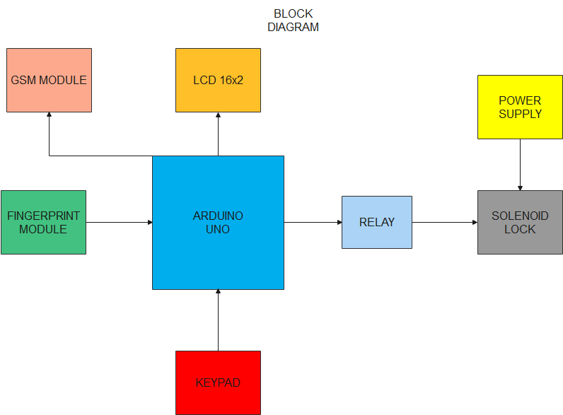

**CIRCUIT DIAGRAM:**

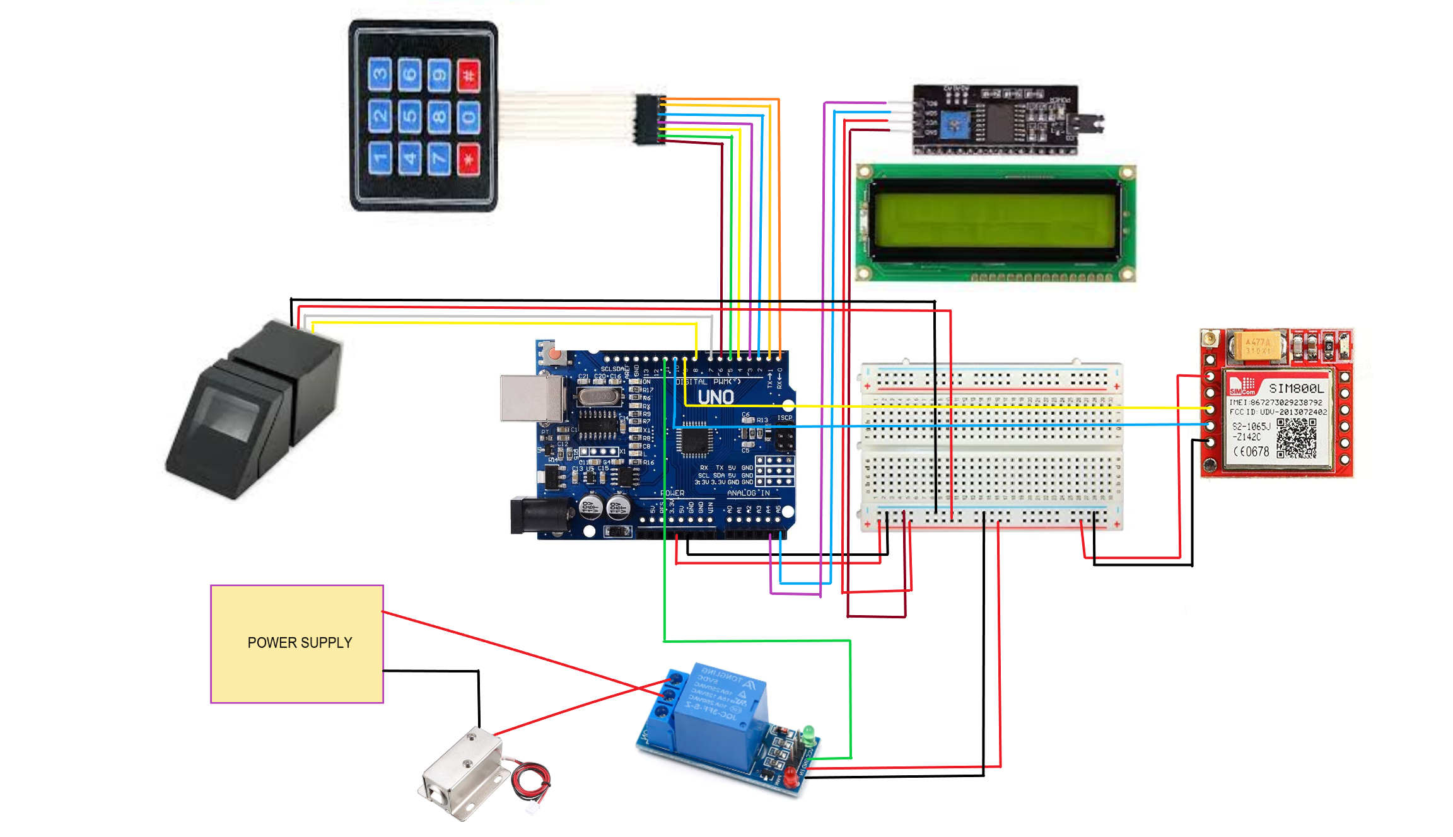

**Conclusion:**

* In conclusion, the methodology outlined for the home door biometric authentication system using a solenoid lock, fingerprint sensor, and Arduino Uno microcontroller aligns with the expectations set in the introduction. The problem of enhancing home security beyond traditional lock and key systems was addressed by leveraging biometric technology, specifically fingerprint recognition.
* The proposed approach of using an Arduino Uno microcontroller to process fingerprint data and control a solenoid lock was successfully implemented in the methodology. The system was found to be effective in authenticating registered users and denying access to unauthorized individuals, thereby meeting the project’s objectives. Thus, there is a clear compatibility between the introduction’s expectations and the results obtained through the methodology.